SHAPE \* MERGEFORMAT 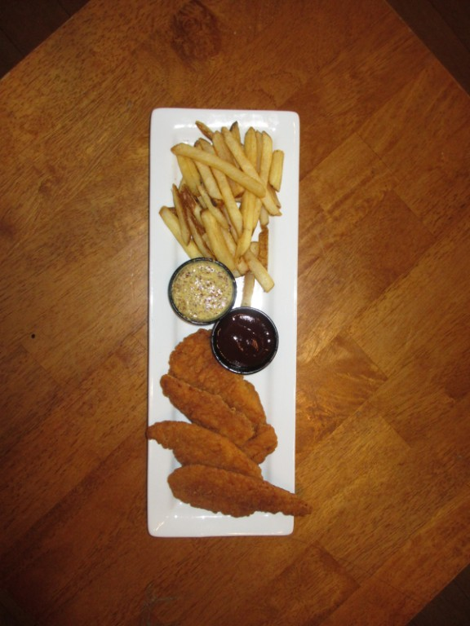
Code | APP-3
Name | Chicken Tenders
Type | Portion
Yield | 1
Shelf Life | n/a
CHICKEN TENDERS
APP-3
Description
Ingredients
Item # | QTY | UOM | Ingredient
 | 4.00 | ea | Chicken Tenders
 | 2.00 | oz | Whiskey Honey Mustard
 | 2.00 | oz | Whiskey BBQ Sauce
 | 4.00 | oz | Fries

Crispy fried chicken tenders served with French fries, our homemade honey mustard, and BBQ sauce

- Fry Tenders in 350 degree fry oil for 3 minutes or until floating and done
- Remove from fryer
- Place on long plate with sauces in ramekins on one side, fries in the middle, and chicken tenders on the other side

Method

